**Data History Upload Instructions**

These instructions detail how to upload past data collected from the Raspberry Pi to an online cloud. For our purposes, we are using OneDrive.

For reference, these instructions are derived from this tutorial: https://jarrodstech.net/how-to-raspberry-pi-onedrive-sync/

Download rclone

1. In the terminal window, enter the following:

curl -L https://raw.github.com/pageauc/rclone4pi/master/rclone-install.sh | bash

Setup your OneDrive account using rclone

1. In the terminal window, enter rclone config

2. Enter n for new connection and press enter

3. Enter a name for the connection (ex: OneDrive) and press enter

4. Enter 23 for “Microsoft OneDrive”

5. Press enter for client ID

6. Press enter for Client Secret

7. Press n and enter for edit advanced config

8. Enter y for auto config

9. A browser window will open. Make sure you have Chromium installed on the Raspberry Pi because the default web browser does not work with Duo’s Two-Step Authentication used by Georgia Tech.

10. Authenticate access to your gatech account and return to the terminal once you are finished

11. Choose 1 for OneDrive Personal or Business

13. Choose the OneDrive you would like to use. (You will probably only have one linked).

14. Select y for yes

15. Select y for yes to save the connection

Commanding the Pi to Upload to the OneDrive

16. On the **Raspberry Pi**, create a folder that will have its contents pushed to the OneDrive. For example, my folder directory is /home/pi/Documents/Research/DataHistory

17. On your **OneDrive**, create a folder that the contents will be uploaded to. Since we are using separate sensor setups, label the folder the name of the sensor station so that other data is not overwritten. THIS IS IMPORTANT!!

18. Open a text file and write the following line:

**rclone copy** THIS IS YOUR LOCAL FOLDER LOCATION **onedrive:**THIS IS YOUR ONEDRIVE FOLDER NAME

As an example, this is written for my specific setup:

rclone copy /home/pi/Documents/Research/DataHistory onedrive:DataSync/Sensor2

19. Save the text file as “synch.sh” inside /home/pi/Documents/Research

You can pretty much save it anywhere on your Pi, however, **do not** save it in the same folder that will have its contents uploaded to the OneDrive. That will end poorly.

20. Make this file executable by going into the terminal and entering the following

chmod +x /home/pi/Documents/sync.sh

Again, this will be different if you have saved the text file in a different location.

Timing the Data Upload

In order to specify when data should be uploaded to the OneDrive, you can set up a command inside the Raspberry Pi to run the “sync.sh” file every x amount of time.

21. In the terminal, enter crontab -e

This opens up the cron’s system that allows you to control when the file will be run. At the end of the file, write code to tell it to upload at 12:30PM every day. For me, it looks like this 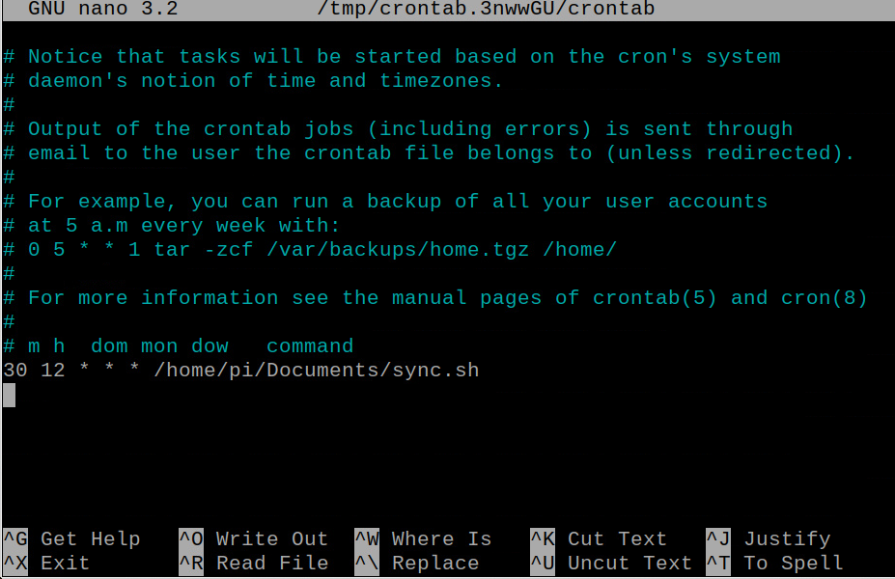

The end.